Maintenance General
FirePro systems that have been installed in accordance with NSCV: National Standard for Commercial Vessels, periodic maintenance must be performed as per the requirements of AS1851: Routine Service of Fire Protection Systems and Equipment.
AS1851 Section 7.4 sets out the requirements for routine servicing in a monthly, six monthly and yearly schedules. Servicing should only be performed by suitably qualified personnel.

Servicing
Must be performed as per AS1851, Sections 6.4.1 and 7.4.2 by accredited service technicians. A logbook must be kept, recording all the relevant information from the installation and servicing
Monthly Servicing should be performed as follows, with any system repairs completed as necessary:
- Servicing should not be performed when the fire control panel is in an alarm/fault condition.
- No personnel should be in the risk area until the fire system is fully isolated.
- Where shutdown relays have been utilised, all personnel should be made aware equipment will not be operable until testing is completed. Shutdown Isolation Module (P/N 98510) may be used to bypass shutdown relays and allow for normal operation of connected equipment during testing.

Visual Inspection

CIE and installed components should be accessible and free from debris, rust, electrical faults, or other damage.

Inspect CIE to ensure normal functioning.

All anti-tamper seals and travel pins should be in place and secure.

CIE, warning signs and strobes should be clearly visible.

Ensure that all FirePro Aerosol Generators have not been discharged and seals are intact.

Inspect the risk area to ensure that the risk has not changed from the approved design.

Review base data for any changes in environment or equipment installed.

Testing

Testing functions will vary based on type of Control Panel. The specifics of each system will need to be understood prior to any testing.

Tests should include a full function test of the installation.

Date of Service |  | System Identifier  Description
Service Completed by: | Name
 | Signature | Vessel

MONTHLY SERVICE REQUIREMENTS |  | AS 1851 – 7.4.2
 | Item |  | Pass/Fail | Action / Comments
1.1 | Electrical detection and control systems. Perform service as per Section 6.
1.2. | Warning signs (and labels) CHECK all signs are visible and legible.
1.7. | INSPECT the protected area to and verify to baseline data. Any changes from the approved design (e.g. volume, fuel type, change of use).
1.8 | Aerosol units CHECK generators have not been discharged and are secure.
1.9 | Aerosol generator moisture seal CHECK that all moisture seals are secure.
SIX MONTHLY SERVICE REQUIREMENTS |  | AS 1851 – 7.4.3
2.1 | COMPLETE all monthly service activities.
2.2. | Electrical detection and control systems Perform service as per Section 6.
2.7. | Manual release systems TEST operation of all manual release systems.
2.9 | CHECK aerosol generators are clear and unobstructed, correctly aimed and secured.
YEARLY SERVICE REQUIREMENTS |  | AS 1851 – 7.4.4
3.1 | COMPLETE all Monthly and Six monthly service activities.
3.2 | Electrical detection and control systems Perform service as per Section 6..
3.10 | Dampers CLEAN dampers and remove any debris.
3.11 | CHECK for any condition that could cause inadvertent discharge of system.
3.12 | Type of hazard VERIFY fuel class and type match baseline data.
3.13 | Enclosure volume (total flooding systems) VERIFY to baseline data
3.14 | Design concentration or application density VERIFY to baseline data.
3.15 | Dimensions of protected objects (local systems) VERIFY to baseline data.
3.18 | INSPECT all areas adjacent to the protected area to ensure that migration of extinguishing agent does not create a hazard.
3.19 | Test operation of automatic ventilation dampers.
3.20 | System interfaces with HVAC systems, see Clause 1.12 and Section 10
3.21 | TEST the operation of the post-discharge system.
3.23 | System interface test (see Clause 1.12.2)  (a) CONDUCT system test with other interfaced fire systems (e.g. HVAC, EWS).  (b) VERIFY functions in accordance with the building’s systems interface diagram.
3.24 | REPLACE any Aerosol generator that will exceed service life prior to next service.
10 YEARLY SERVICE REQUIREMENTS |  | AS 1851 – 7.4.5
4.1 | Monthly, Six monthly and Yearly service COMPLETE all activities required

System Test – FP-08450 Control Panel
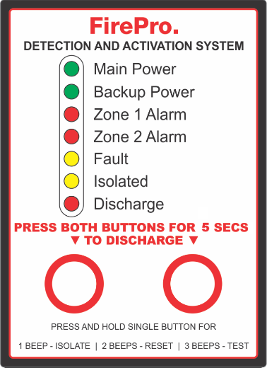
Testing should be performed when the fire control panel is not in an alarm/fault condition. Note: No personnel should be in the risk area until the fire system is fully isolated.
Note: Where shutdown relays have been installed, all personnel should be made aware equipment will not be operable until testing is completed.
- Isolate the control panel and disconnect the any installed FirePro aerosol generators. This will generate a fault on the fire control panel.
To isolate the control panel, press and hold Mode Switch 1 until a 1 beep is heard and the “Isolated” LED is illuminated.
To restore the control panel to normal operation, press Mode Switch 1 and ensure the “Isolated” LED turns off.
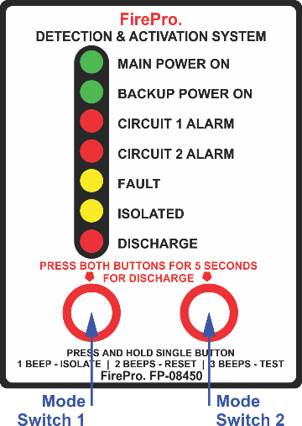
Isolating disables automatic activation. Manual Activation will remain operational.
When isolated, the control panel continues to monitor for alarm and fault, and show the alarm and fault indications, but will not operate the siren and the automatic discharge. When isolated, any change in the detector status, will cause the panel sounder to operate for 1 second as an alert of the status change, but the panel will remain isolated.
The isolate function will also silence the siren/strobe and the internal sounder but will not cancel the alarm or fault indication.
- Connect a FP-08800 Universal Test Lamp to the “Discharge” output to the panel (marked yellow). Turn off the Isolate function.
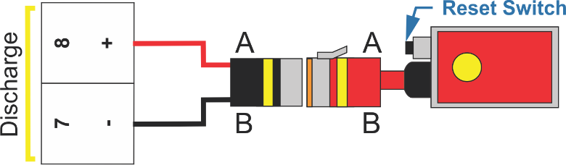
- Inspect installed FirePro generators to ensure they are in good condition, and that the relevant stream lengths and thermal clearances are observed.
- Test the fault monitoring system by disconnecting and reconnecting all connected detection devices and the siren strobe circuit one at a time. Ensure the “Fault” LED indicator illuminates and the internal sounder is heard each time a circuit is disconnected.
- Test the detection circuit(s) and ensure that any alarm condition activates the siren.
- Manual Discharge Testing:
- Perform a manual discharge test by pressing and holding both mode switches continuously for 5 seconds.
- Following the activation sequence, ensure the test lamp has operated.
- Isolate the panel to silence the alarm. The control panel should now display a fault.
- Reset the connected test lamp by pressing the reset button on the lamp. The control panel should no longer be in alarm/fault condition.
- Turn off the Isolate function.
- Automatic Discharge Testing: Not Allowed under Marine Regulations. The panel must not be programmed for automatic discharge, unless manual call points are installed. If no call points installed skip to step 7.
Each detection device connected to “Circuit 1 Alarm” must be tested individually.
- Perform an automatic discharge test by activating each of the manual call points.
- Following the activation sequence ensure the test lamp has operated.
- Isolate the panel to silence the alarm. The control panel should now display a fault.
- Reset the connected test lamp by pressing the reset button on the lamp.
- Reset the control panel by pressing and holding a single mode switch until 2 beeps are heard. The control panel should no longer be in alarm/fault condition.
- Turn off the Isolate function.
- While performing discharge test, ensure operation of all installed siren/strobes. These must be audible and visible at all points of the risk area.
- While performing discharge test, ensure operation of all installed shutdown relays. This should include shutdown of fuel supply, forced air ventilation and any other equipment specified in the system design and risk assessment.
- Individually test the function of all connected detection devices. Testing method will depend on the specific device - check product manual if unsure.
- Ensuring the control panel is not in an alarm/fault condition, isolate the control panel.
- Disconnect the FirePro FP-08800 Universal Test Lamp and reconnect all installed FirePro aerosol generators.
- Turn off the Isolation function. System is now operational.

Logbook to be updated

Review the whole system for fitness of purpose.

System Test – FP-08350 Control Panel – Discontinued in 2016
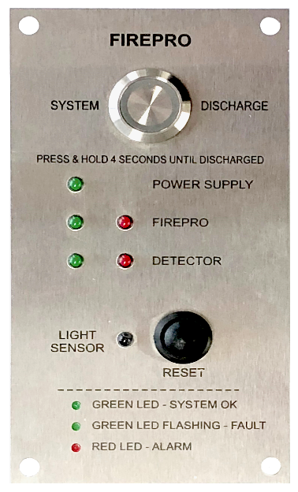
Testing should be performed when the fire control panel is not in an alarm/fault condition. Note: No personnel should be in the risk area until the fire system is fully isolated.
Note: Where relays have been used, personnel should be aware equipment will not be operable until testing is completed.
- To isolate - disconnect the any installed FirePro aerosol generators. This will generate a fault on the fire control panel.
There is no isolate built into the control panel.
- Connect a FP-08800 Universal Test Lamp to the “Discharge” output to the panel (marked yellow).
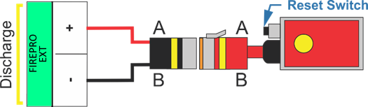
- Inspect installed FirePro generators to ensure they are in good condition, and that the relevant stream lengths and thermal clearances are observed.
- Test the fault monitoring system by disconnecting/reconnecting detection devices. Ensure the “Fault” LED green indicator flashes each time a circuit is disconnected.
- Test the detection circuit(s) and ensure that any alarm condition activates the siren.
- Manual Discharge Testing:
- Perform a manual discharge test by pressing and holding the ACTIVATION switch continuously for 4 seconds.
- Following the activation sequence, ensure the test lamp has operated.
- Press the RESET to silence the alarm. The control panel should now display a fault.
- Reset the connected test lamp by pressing the reset button on the lamp. The control panel should no longer be in alarm/fault condition.
- While performing discharge test, ensure operation of all connected relay functions. This may include shutdown of fuel, ventilation, or other equipment.
- Disconnect the FirePro FP-08800 Universal Test Lamp and reconnect all FirePro units.

Logbook to be updated

Review the whole system for fitness of purpose.

