SERVICE PERSONNEL - Service of fire protection systems, including daily operator inspections, shall be performed by a competent person. The competent person is to be accredited to the level required for the service being conducted.

RECORDS - Records shall be retained by the owner and shall include the following details:
- Service activities.  - Defects.  - Rectifications and by whom.  - Date conducted.  - Risk Assessment | - Baseline data. including:  - System discharge sequence alarms, time delays and shutdowns.  - Enclosure gross volumes for total flooding systems.  - Agent type, Number of generators, Application density.  - Replacement Date of FirePro Units.  - Type of detection fitted, Number and location of actuators.  - Date of initial install and service life of all items.

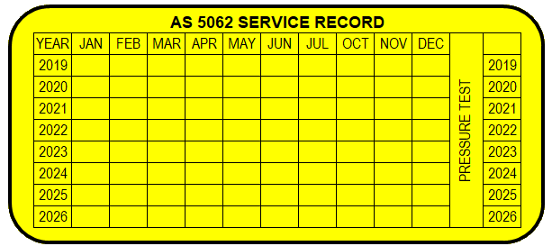
SERVICE TAG or LABEL - A service tag or label is be provided for each fire protection system to record the last level of inspection, test and survey performed.
The level of service carried out shall be etched, stamped, or indelibly marked on the tag or label in the box corresponding to the year and month in which the routine was performed, with a figure representing the routine as follows:

PRECAUTIONS - Prior to commencing any service activity, the system is to be isolated to prevent activities from causing discharge of any extinguishing agent.

DEFECTS - Critical defects shall be rectified with the minimum of delay and before the mobile or transportable equipment is operated. Critical defects shall be reported to the responsible entity and confirmed in writing within 24 h. Unless alternative risk reduction measures are implemented for the safety of personnel, equipment shall not be operated until the critical defects are rectified. An 'out-of-service' tag is be used to indicate that the system is impaired. Non-critical defects shall be rectified as soon as practicable and reported to the responsible entity.

SCHEMATIC OF SYSTEM

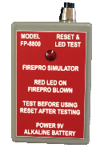
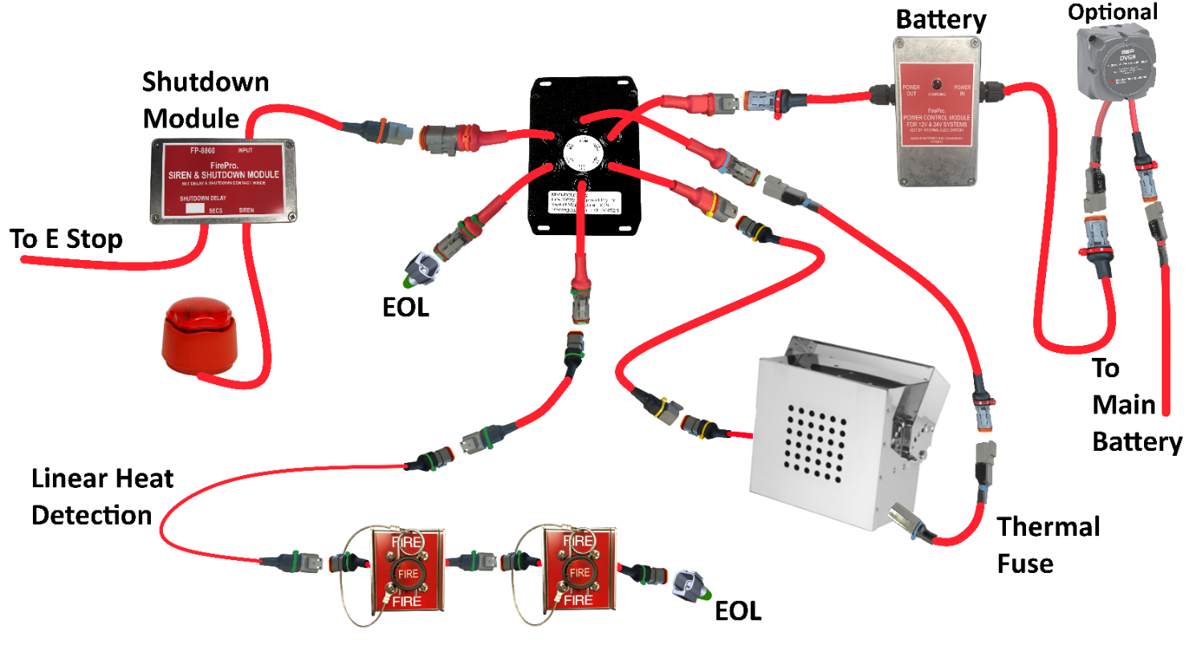
Plug in Simulator before any work.

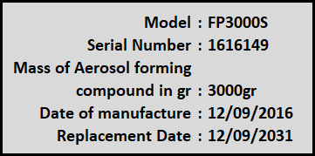
SERVICE LIFE OF FIREPRO AEROSOL GENERATORS
The service life of the FirePro Aerosol Generators is 15 Years (was 10 Yrs) this was certified after additional testing from Underwriters Laboratory UL in Dec 2016. The replacement date is shown on the label for each FirePro Generator. This replacement date is subject to regular inspection of the units as installed and no visible damage noted.

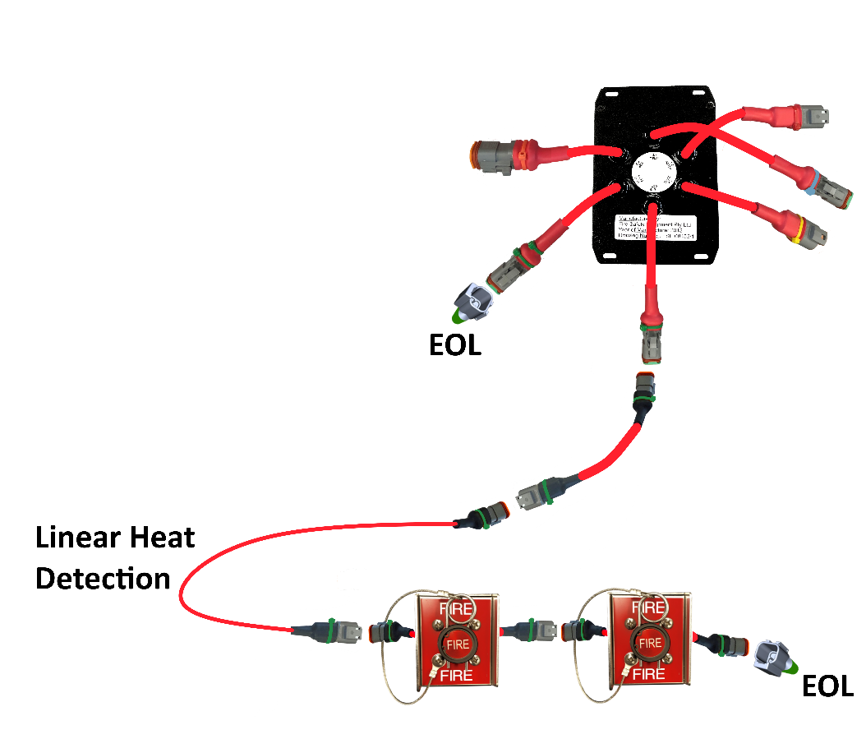
TECHNICAL NOTES

DETECTION CIRCUIT 1 – This is the only way that the system can activate – other than directly from the Control panel.

The connections in this circuit are important to be protected from water ingress. The circuit will activate based on a SHORT Circuit. If the Linear heat Detection operates during a fire – it creates a short, likewise the manual activators.

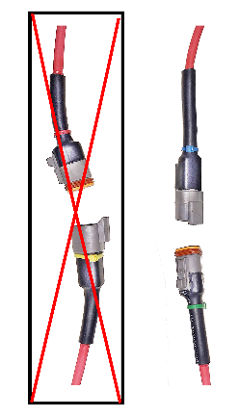
Water in the Deutsch plug connections will create an activation. equipment is operated.

Plugs should be installed with the female plug pointing down as shown.

It is recommended to cover the connections with additional Heatshrink to create another layer of protection.

Check CONDITION of Cable – Replace as necessary
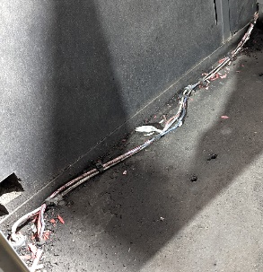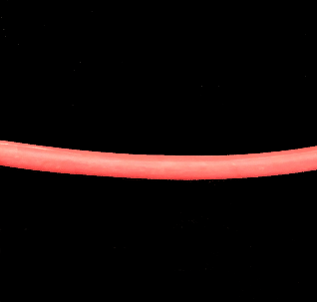
Recommended
Install in conduit
where exposed
What cable should look like.
Cable Damage
Cable Damage
SOUNDER FAULT (3 or 4 Beeps Version 4 Panel Only) panel will display a fault if incoming power drops below 9.0v DC.
ALL OTHER CIRCUITS – are not capable of activating the system. Any damage or water ingress will be reported as a fault on the panel. The panel will beep in a coded fashion to indicate which circuit is in fault.
Internal Sounder | Fault LED | Fault
1 beep | On | Circuit 1 Alarm
2 beeps | On | Circuit 2 Alarm
3 beeps | On | Discharge Circuit
4 beeps | On | Siren/Strobe Circuit – Version 4 Panel Only
POWER SUPPLY – the most likely cause of problems will be incoming power supply
Operating Voltage of Panel | 9-30vDC – panel will fail below 7.5vDC
Battery Charging Voltage | 25vDC – LED indicates Charging
Backup Supply takes over when incoming supply drops below | 25vDC
ALL OTHER CIRCUITS – are not capable of activating the system. Any damage or water ingress will be reported as a fault on the panel. The panel will beep in a coded fashion to indicate which circuit is in fault.
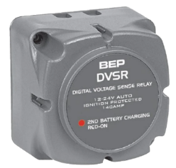
OPTIONAL Voltage sensitive relay – not installed in all Atlas Machines.
Where installed it will monitor the incoming power supply. The incoming power supply must drop below 25.6v DC voltage continuously for 4 seconds before the DVSR will automatically cut off the incoming power supply. Engages when machine battery voltage is above 26.8vDC.

Date of Service |  | Machine Identifier  Description
Service Completed by: | Name
 | Signature | Branch / Location

SIX MONTHLY SERVICE REQUIREMENTS
 | Item | Pass/Fail | Action / Comments
1. | Isolate the system – this process will vary. Refer to manual for each panel.
2. | Control panel  - Clean and remove dirt, grease and foreign material. Replace any parts that appear damaged or are painted.  - Check that all indicators show normal condition.
3. | FirePro Aerosol Generators  - Inspect FirePro generators to ensure they are in good condition.  - Check mounting brackets are in good condition and secure.  - Check Dust Covers are in good condition – replace as necessary.  - Check FirePro Generators are at predetermined aiming points
4. | Electrical system – Inspection  - Check Manual Actuators are secure, clean, undamaged.  - Check that anti-tamper seals/pull pins are in place and secure.  - Check all wiring, connection and supports are intact, not damaged and in correct position.
5. | Labels Check manual release, system warning and instruction labels are securely in place, visible and legible.
6. | Test the fault monitoring system by disconnecting and reconnecting all connected detection devices and the siren strobe circuit one at a time. Ensure the “Fault” LED indicator illuminates and the internal sounder is heard each time a circuit is disconnected.
7. | Discharge Testing from Control Panel  - Perform a manual discharge test by pressing and holding both mode switches on the panel continuously for 5 seconds.  - Following activation, ensure the Test Module Red LED has operated.  - Isolate the panel to silence alarm. Panel should now display a fault.  - Reset Test Module. Panel should no longer be in fault condition.  - Turn off the Isolate function.
8. | Discharge Testing from External Devices:  Each detection/manual actuator device installed must be tested individually.  - Perform automatic discharge by activating the detectors or manual actuator.  - Following the activation ensure the Test Module Red LED has operated.  - Isolate the panel to silence alarm. Panel should now display a fault.  - Reset Test Module. Panel will stay in alarm until reset.  - Reset the control panel by pressing and holding a single mode switch until 2 beeps are heard. Panel should no longer be in alarm/fault condition.  - Replace Anti-Tamper Seals on Manual Actuators.
9. | System control and indicating equipment.  - During discharge test, ensure operation of all installed siren/strobe(s).  - During discharge test, ensure operation of all installed shutdown relays. This must shutdown any equipment specified in the risk assessment.  - Test backup battery capacity. Replace backup battery every 2 years.
10. | Design Survey - check against the baseline data, for alterations, changes in use or operating environment, or other factors that could affect the performance of the fire protection system.
11. | Update Service Tag – and logbook
IMPORTANT: Testing should be performed when the fire control panel is not in an alarm/fault condition.

Date of Service |  | Machine Identifier  Description
Service Completed by: | Name
 | Signature | Branch / Location

ANNUAL SERVICE REQUIREMENTS
 | Item | Pass/Fail | Action / Comments
1. | Complete all 6 monthly routine service activities – this process will vary. Refer to manual for each panel.
2. | FirePro Aerosol Generators –  - Check listed manufacture date for installed FirePro generator. Replace any generator that has exceeded service life.  - Check that installation location of FirePro generators and coverage remains appropriate.
3. | Actuation system –  - Conduct continuity test on actuation circuit. This will require a multi-meter.  - Function test all circuits  - Check all wiring for earthing
4. | Detection System –  - Function test all detectors  - Check all wiring for earthing  - Check that detector coverage remains appropriate. In particular, check for the presence of unprotected areas where sources of fuel and heat exist.
5. | System Interface and Shutdown system –  - Ensure all equipment shutdowns operate on system alarm  - Record delay time and compare with delay set during install. If the delay time has changed from install, it will need to be rectified. Cause of change must be recorded.
6. | Discharge Testing from Control Panel –  - Perform a manual discharge test at the control panel, as per 6 monthly service.
7. | Discharge Testing from External Devices –  - Perform automatic discharge by activating the detectors or manual actuator, as per 6 monthly service. Each detection/manual actuator device installed must be tested individually.
8. | Operational Conditions –  - Check that the detector response and extinguishing agent discharge or retention will not be adversely affected by such things as enclosure openings, ventilation airflows or high temperature protected areas.
9. | Environmental Conditions –  - Check that the fire system and its components are suitable for the environmental conditions in which the machine is operating, e.g. that components are suitable for underground mining, and road gradient and slopes are within container orientation limits.
10. | Design Survey - check against the baseline data, for alterations, changes in use or operating environment, or other factors that could affect the performance of the fire protection system.
11. | Risk Assessment – required to be reviewed every 5 years or after any incident. Review document to ensure system compliance. Check if document is current.
12. | Update Service Tag – and logbook
IMPORTANT: Testing should be performed when the fire control panel is not in an alarm/fault condition.

